WiZiQ Virtual Classroom for Online Education

“WiZiQ is incredible. Just led my Thursday class in Baltimore from
a park bench in NYC. Wow! I’m really impressed.”

Shelly Blake-Plock
D eli v er en ga gi n g t ea c h i n g a n d lea rn i n g e x peri e n c es t o a n y on e , a n yt i m e , a n yw he r e

iZiQ Virtual Classroom gives you the teaching experience that no other virtual classroom does - A teaching environment that delivers media-rich content while removing geographical barriers. WiZiQ’s easy-to-use Virtual Classroom provides an edge over the traditional classroom mode - takes your teaching
expertise beyond the four walls of the traditional classrooms, to students, wherever they are located.

Using WiZiQ Virtual Classroom, an educator can provide learning opportunity to all participating students. All students need is a web connection.

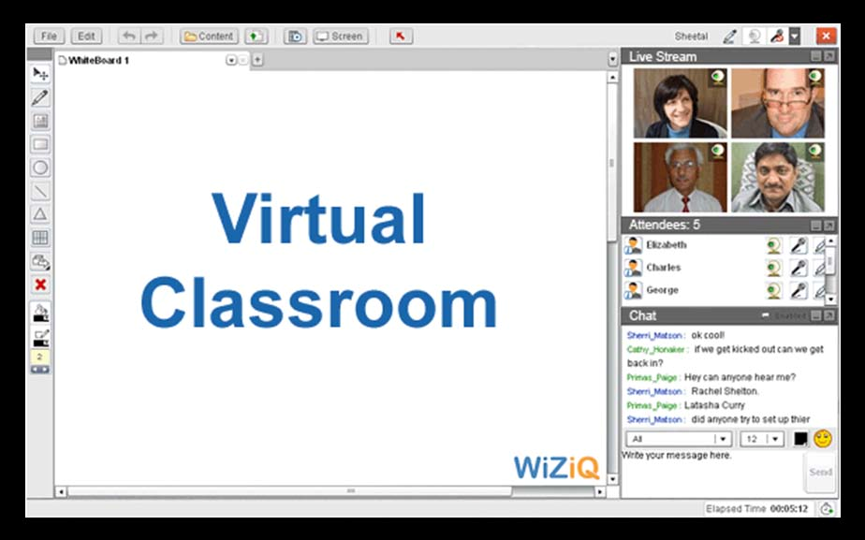

1

Ease of Use

No Downloads, Instant Access – keeps the focus on the content, and not on technology

“No annoying downloads and WiZiQ’s Flash- based learning environment works on any web browser and on
any operating system.”

Zaid Ali Alsagoff
Available from the web

WiZiQ virtual classroom offers a very simple user interface which lets you focus on your teaching - not the technology. An easy-to-use tool works on any operating system and requires no installation or changes in the user's system or training. You simply have to log in to start. However, a WiZiQ training team offers any kind of assistance to teachers and students.

Familiar menu and shortcuts

So you don’t have to spend extra time and energy to get acquainted with the environment and remember the new shortcuts – we’ve tried to make it as simple and as familiar as it can be. Just like Windows it has File, Edit, Settings, etc., options and short cuts like - ctrl+c, ctrl+s, ctrl+v, etc.

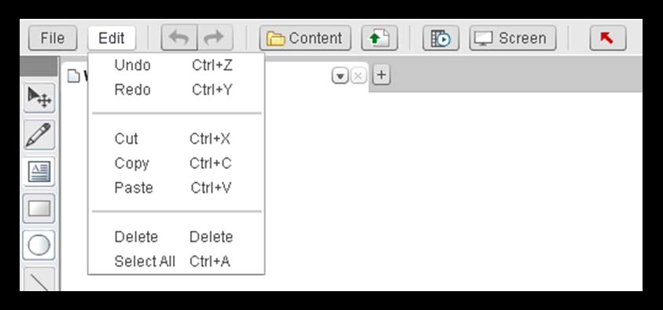

2

Show, Tell and Engage

Makes learning easy, effective and enjoyable – not a slow, cumbersome ordeal

Live Chat

“I love WiZiQ. This morning I got a lot done in just one hour. It’s a great tool, which lets you optimize your time.”

Alexandro
Colorado

WiZiQ Virtual Classroom provides a hassle-free two-way, real-time communication between the students and teacher through live chat. Similar to face-to-face conversation in the traditional, physical classroom, chat occurs between the teacher and student in real-time with immediate replies. A teacher can have private text chat with a student or with multiple students simultaneously.

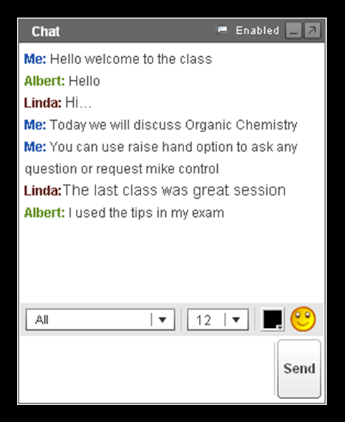

3

Show, Tell and Engage

Addresses a variety of learning styles – Use your own language to teach and interact

Teach in your language

“I can now realize my idea to teach online not just in Europe but around the World and in my German language.”

Karin Jahn

Learning best happens when it’s done in the language students’ best understand. We support almost all the languages of the world. You can chat in any language you or your students are comfortable in - Spanish, French, or Right-to-Left languages like Arabic, Urdu, Hebrew, etc.

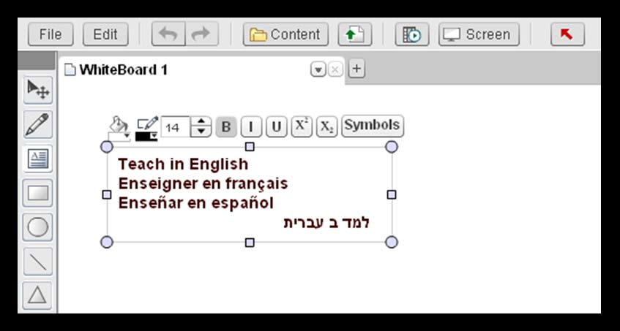

Time extension

Now, you don’t have to worry about keeping track of time while in the classroom. On the whiteboard, a pop-box appears 5 minutes before your class ends. You get five minutes of time to wrap up your class or extend the time, if required.

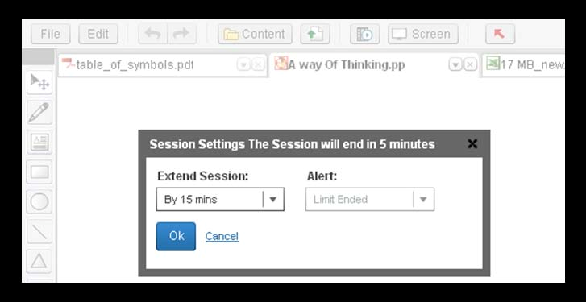

4
Show, Tell and Engage

High impact video, audio and interactivity creates an almost-in-person experience

“I love WiZiQ. It has enhanced my teaching abilities in a Virtual
Classroom and my students love it.”

Will Edmond
Live Audio/Video

Creates in-person experience through live audio/video streaming for all attendees. With built in flash technology and state of the art peer-to-peer technology just like Skype, you can have seamless audio/video communication with multiple students – also have up to 4 live video streams at the same time in the virtual classroom. All this with no plug-in needed.

Complete Control

You control students’ participation. We have designed it so you can teach effectively in the virtual classroom while reaching your overall goals. You can allow students to speak in the class - by giving them the audio control, let them share their video - by giving them video control and allow them to write on the whiteboard - by giving them writing control. All these controls or any one of them can be taken and given at any time during the class duration.

Transfer Writing Controls

Transfer Audio Controls

5

Share Anything

Share Adobe PDF documents, Excel Sheet, PowerPoint and Word Document for easy and more secure communication, collaboration, and timesaving electronic workflows

“Five continents collaborating via a new free tool. That is amazing. The potential of this
tool is greater than my coffee deprived mind can fathom.”

Ms Duff
Document Sharing

You can share documents in any format - video/audio files, PDFs, Word documents, Excel sheet, SWF files and PowerPoint presentations with the students in the Virtual Classroom. You can directly pick them from your WiZiQ content repository (you will have to upload them before the class) or upload them from their current location.

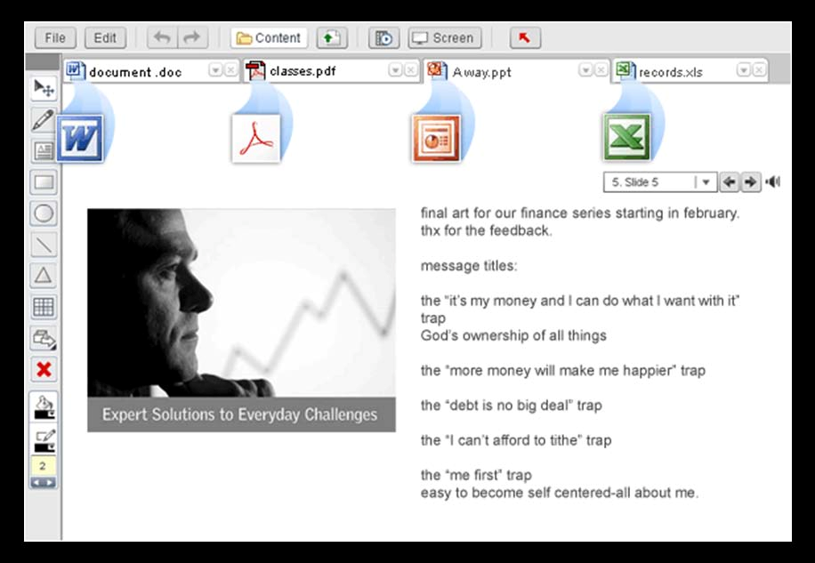

9

Share Anything

Engage students by demonstrating live usage of software/application in real time

Desktop Sharing

“It looks really promising as a way to hold free
online meet ups for classes and discussions. I was very impressed
with WiZiQ.” Jeff Utecht

You can share your on-screen activity in real-time with all the students in the Virtual
Classroom by sharing your desktop.

Java Runtime environment (JRE 1.5 or above) needs to be installed (only) at presenters' end to share their screens. It’s a simple-click start and stop function. The students can see you working on the documents, using an application/software or browsing the Internet. Anything you do goes live in the Virtual Classroom and gets captured in the class recording too! Students can also share screens in the class if writing control is transferred to them.

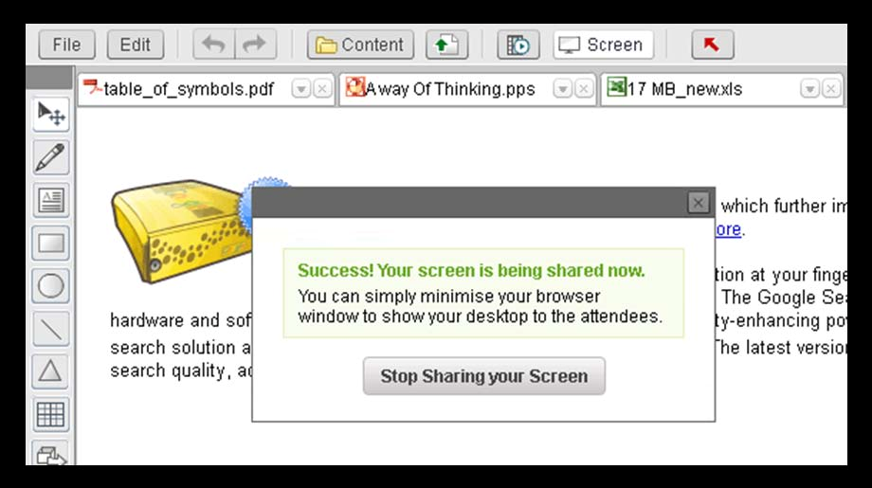

10

Share Anything

Deliver high-quality, on-demand presentations and video without special training

“WiZiQ is the best educational portal that I have come across and you have the potential to earn through this platform.”

Saraswathy
Media Sharing

You can watch videos in the Windows Media Player right in your classroom. You can play any video or audio file by simply clicking on the file name - all the media files that you upload in the content library get listed in the media player. Even better, you can directly paste the URL to play - YouTube videos are directly playable by YouTube URL. You can also minimize media player while the media file is playing for background sound.

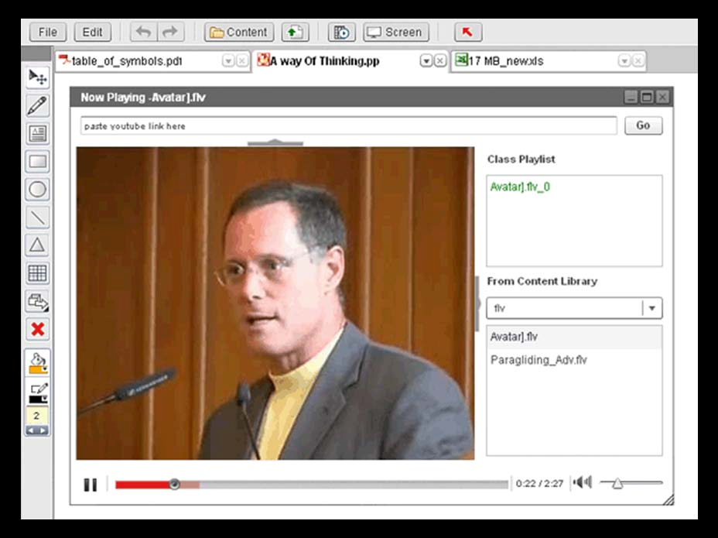

Share Anything

Combine a wide range of content – documents, drawings, e-mail, and spread sheets – in a single portfolio to share with students

“While the synchronous communication tools in our LMS crash and burn (especially the whiteboard function), WiZiQ is stable and great to use.”

Maria H. Andersen
Content Library

Using WiZiQ’s content feature you can save these files in the content repository and share them with your students in the Virtual Classroom. You can upload up to 20 MB files for doc-docx, pdf, xls-xlsx, ppt-pptx-pps-ppsx, swf-flv and 50 MB for mov-avi-mpeg-wmv and wav-wma-mp3. Also embed videos from YouTube, presentations from authorSTREAM and documents from SlideShare to play in the Virtual Classroom. By uploading content you create your personal repository of content on WiZiQ. You can use this content in your virtual classroom; share it with your students, contacts and world.

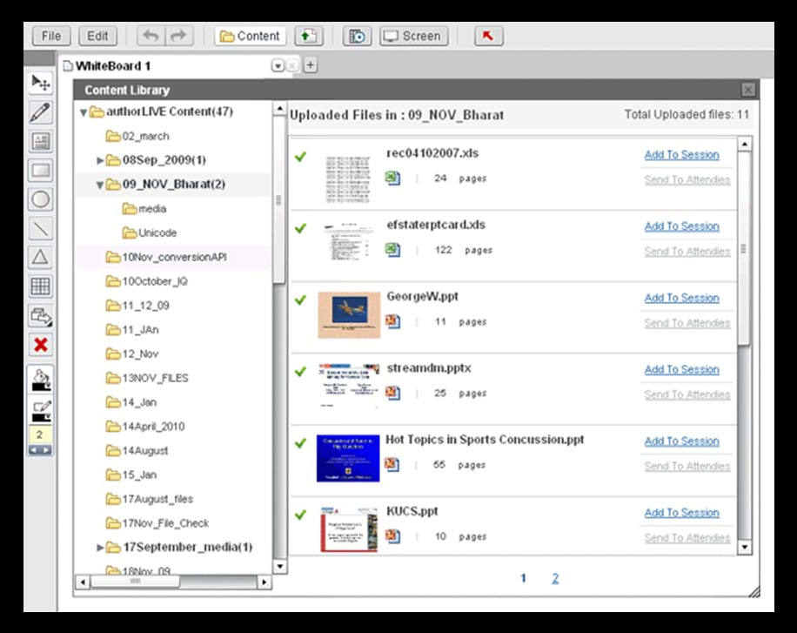

12

Recording

Let Students re-live the Experience

“I currently use both Wimba and WiZiQ but am moving more toward WiZiQ due to its architecture. Plus the audio quality is superior.”

Craig Jackson
Every class that is conducted on WiZiQ is recordable - if you want to. Anything you do in the Virtual Classroom gets captured in the class recording. The recordings play exactly like the real class without any delay or disruption. The class recordings are completely in synch with the media sharing (audio/videos), desktop sharing and content sharing in the virtual classroom.

It saves time for students they don’t have to scribble the notes! They can always go back to the recordings of the class to refresh the concepts. Teachers can watch the recordings to improve their teaching skills. Like the Virtual Classroom, recordings are also accessible from any web browser - since it plays in Flash, no other plug-in required.

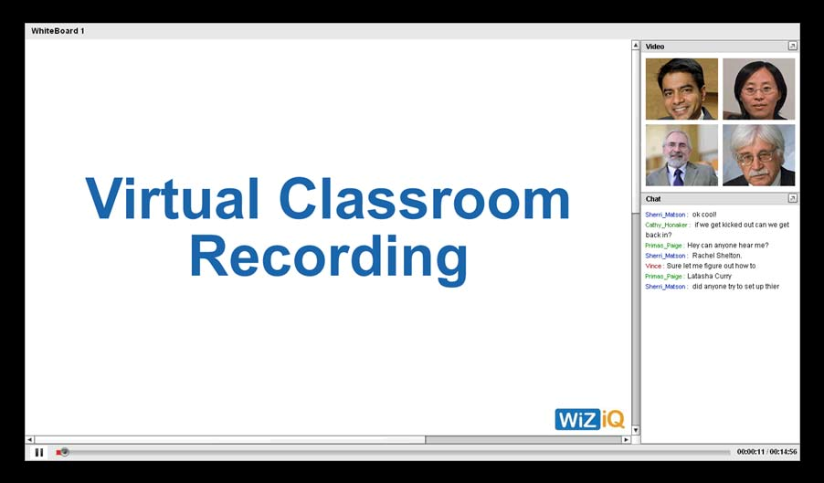

13

Attendance Report

A complete attendance report of the students in the classeWiZiQ briefly and I find it very impressive. The quality of the audio and the fact that PowerPoint animations are
Every time a student enters or leaves a classroom, his log in and log out time is recorded. This process is conducted for all the students who enter the classroom. This way the number of students who attend the class and their time duration is detected and recorded. By the end of the class, the complete attendance report is available.

Teacher can use the report for their own record or send to the parents. They no longer have to worry about keeping a tab on the students; they can entirely focus on teaching. This attendance data can be sent to other applications like an attendance management system or a course management system.

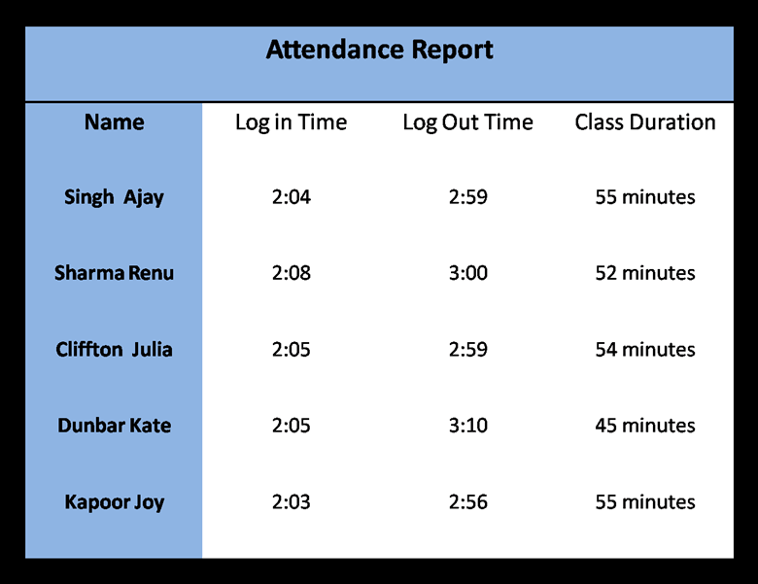

14

